1. After downloading the software from the location above, run the installation to place the Handheld Software firmware upgrade on your computer for installation. Delete the vendor.xml file located at C:\Program Files\Common Files\Research In Motion\AppLoader
2. Start up the Blackberry Desktop Manager. Then connect your Blackberry handheld device via the USB cable to your computer. Once it has connected, click on the Application Loader option in the bottom center of the window.
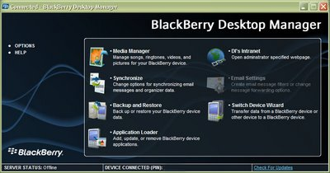
3. The Blackberry Application Loader Wizard will fire up, click on next to continue.
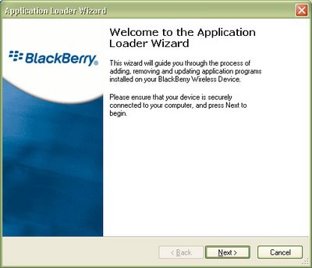
4. Now enter the PIN or security code in the Application Loader Wizard to continue and click on next.
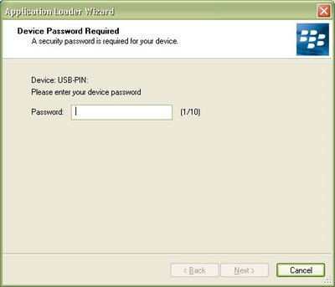
5. Now the available updates for your Blackberry device will appear. Choose the appropriate languages and applications and click on next.
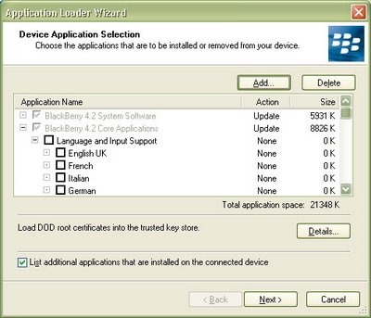
6. Leave the option selected to automatically back up your Blackberry device application data and also the checkbox for including the messages.
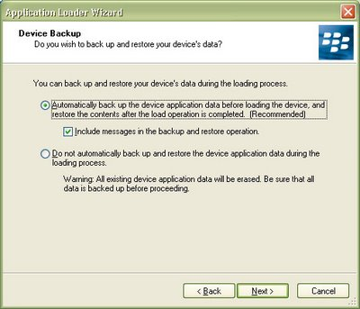
7. The Application Loader Wizard will confirm you selections before starting the upgrade process on your Blackberry.
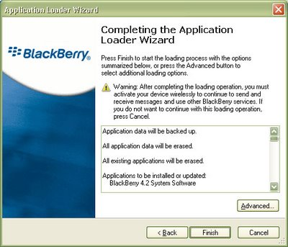
8. The Blackberry Application Loader Wizard will begin updating your device. It will take approximately 15 minutes, including a reboot of your device to complete the upgrade.
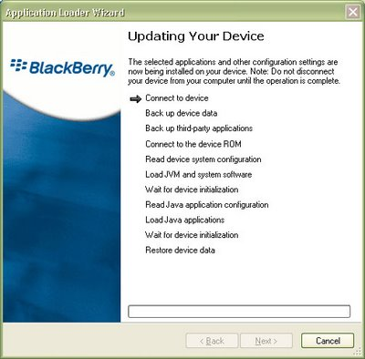
9. The upgrade of your Blackberry device was successful, congratulations! Click on the close button to complete the process and reconnect your Blackberry to the Desktop Manager software.
